**WEEK 5 – Task 16: Mini Project**

Using Quartile Functions, outliers are found and removed. To do this, I will have calculated the 1st and the 3rd quartile, and then using it calculate the upper and the lower limit and found 3 outliers.

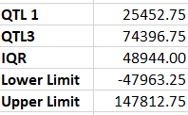

**Q1.** How many males and females are Hired?

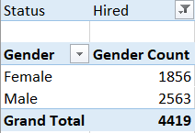

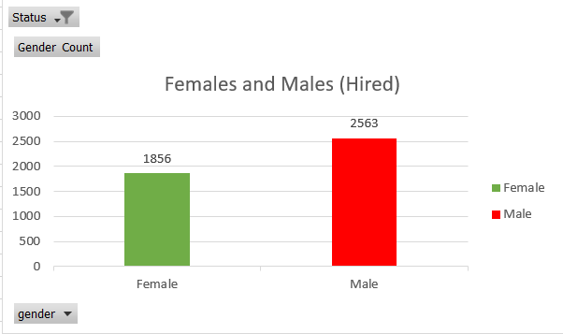

**Q2.** What is the average salary offered in this company? (removed outliers and null value)

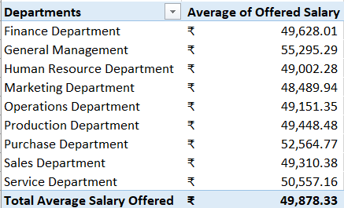

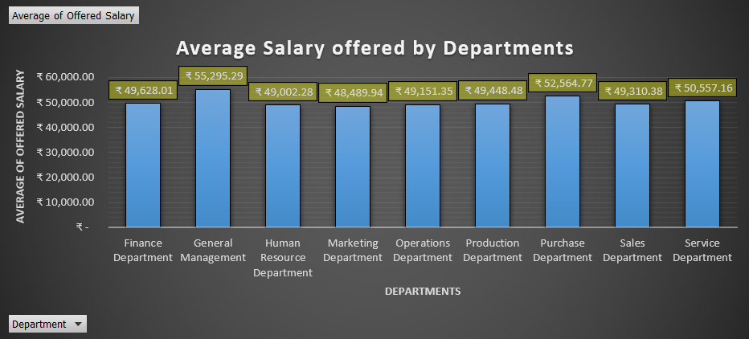

**Q3.** Draw the class intervals for salary in the company?

For this question we have removed ₹100.00 along with blank value from Offered Salary column as both are too small to count.

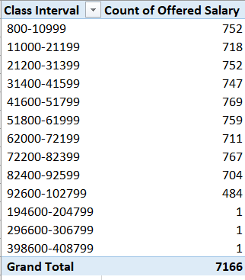

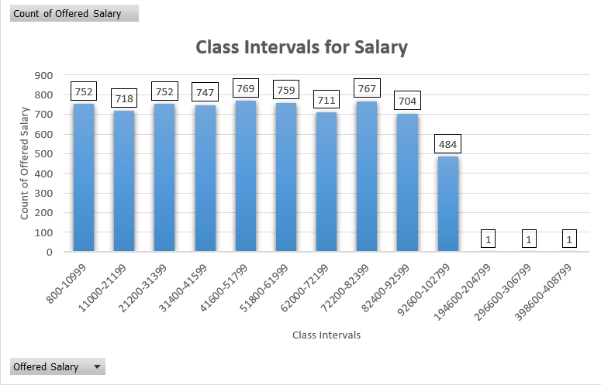

**Q4.** Draw Pie Chart / Bar Graph (or any other graph) to show proportion of people working different department?

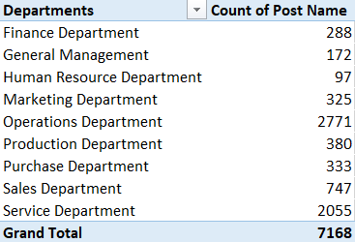

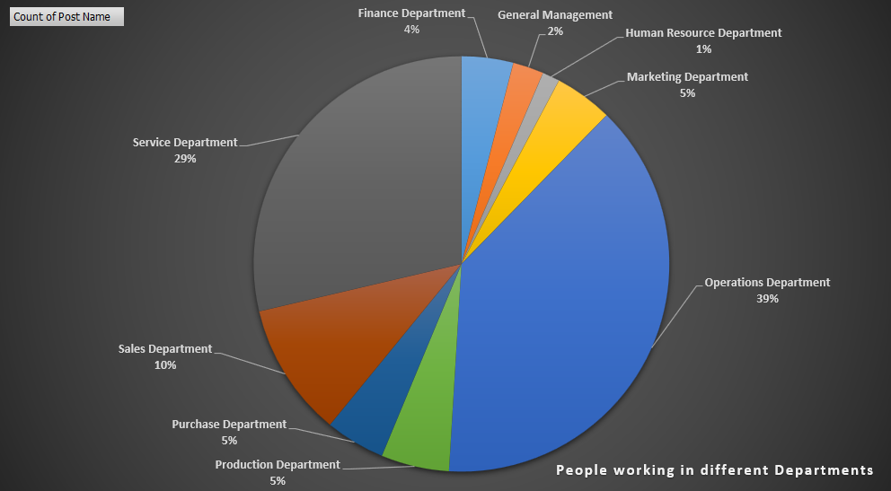

**Q5.** Represent different post tiers using chart/graph?

